UNIVERSITY OF THE EAST

Rating
152 Samson Road, Caloocan City
College of Engineering
Information Technology Department

CCP1101 – COMPUTER PROGRAMMING 1
Module __ : Activity __

Name | RAMIREZ, Ishmael L. | Section: | IT2G
Student Number | 20201132141 | Professor: | Celis, J. R. E.

INSTRUCTIONS:
- For each problem, paste the code and sample output here.
- Make sure your name and student number are printed at the end of the output.

EXAMPLE:

Sample Problem:

Create a Python program that accepts two numbers, then displays the sum, difference, product, and quotient.

Code: Sample Output:
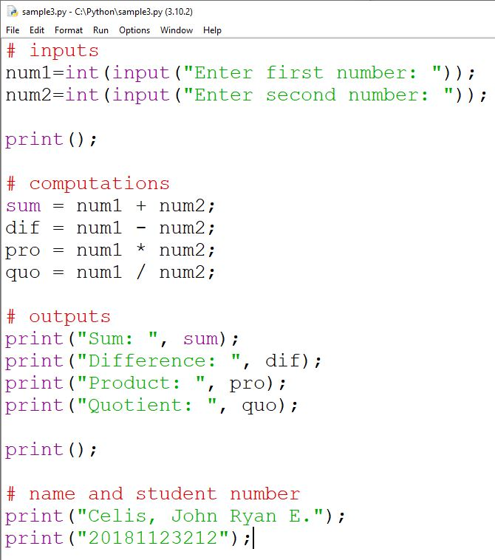
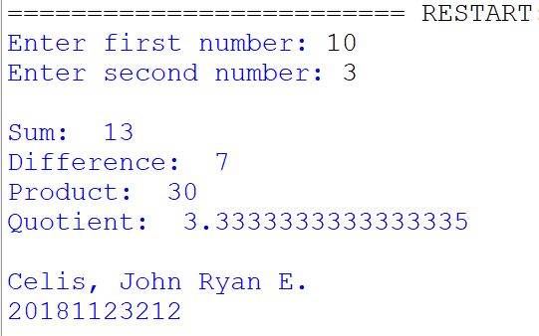

Problem:
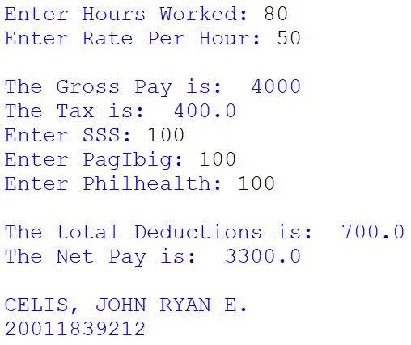
Create a C++ program that computes an employee’s salary. The program should accept the employee’s Hours Worked, Rate Per Hour, SSS, PagIbig, and Philhealth. The program will then display the Gross Pay, Tax, Deductions, and Net Pay.
Consider the following computations:
Gross Pay = Hours Worked * Rate Per Hour
Tax = Gross Pay * 0.1
Deductions = Tax + SSS + PagIbig + Philhealth
Net Pay = Gross Pay – Deductions
Consider this sample output. Follow the flow of the program:

NOTE:
I WILL CHECK YOUR PROGRAM FIRST BEFORE YOU SUBMIT THIS FILE IN CANVAS.
Code:
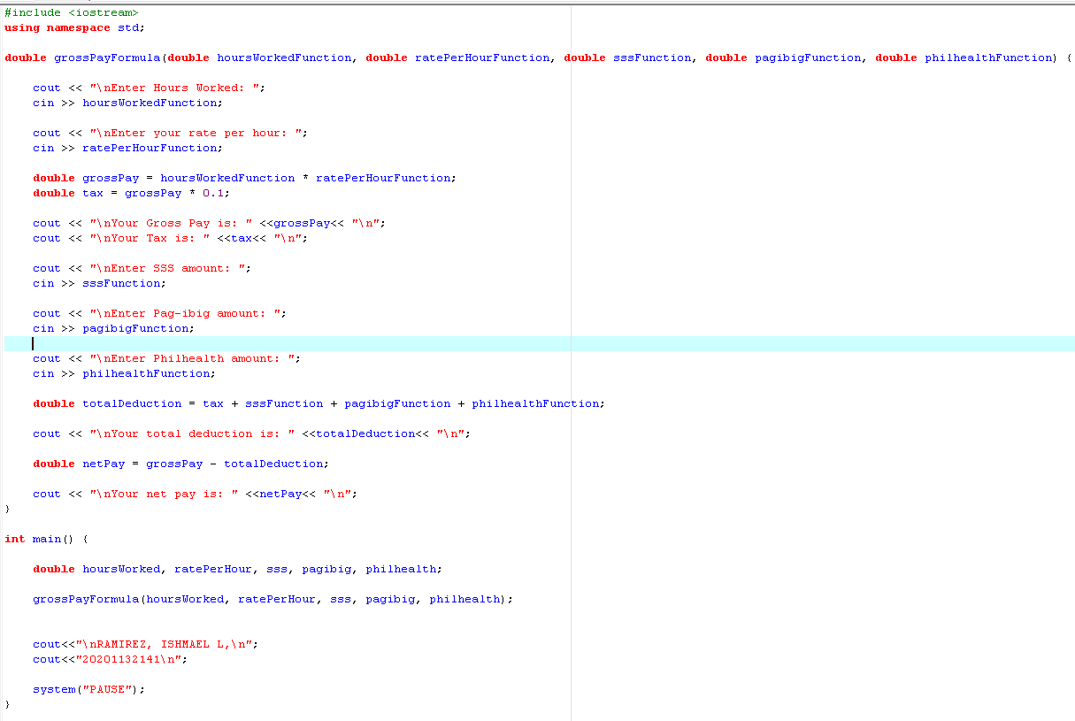

Output:
